**Broad goals**

1. Create the database with user accounts & banking data
2. Get java connected with the database
3. Create an abstract class, then a class for each method detailed:
   1. As a user I can login and logout.
   2. As a user I can view my balance.
   3. As a user I can withdraw money.
   4. As a user I can deposit money.
4. Fill out requirements:

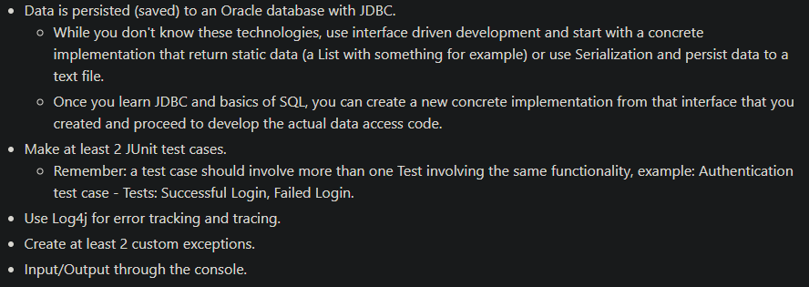

DON’T FORGET to have 2 custom exceptions

**Specifics**

For 1)

Main table will hold the user information including:

Account_Number (primary key)

Login_Username (varchar)

Login_Password (varchar)

Current_Balance (float)

For the console:

Use a get bank account info pass in the values that the user inputed through the scanner previously.

So whenever the user enters their information, they have it stored in some values:

Username

Password

These variables are then accessed whenever the user makes a choice of 1

Console:

Have a switch statement that allows the user to login, check balance, withdraw money, deposit money, and logout

**Need to have add exception testing**

**If a user enters an invalid character, it currently will crash the program**